Washington State Agricultural Education CDE
2022 Written Test

- The purpose of agricultural education is to:
  - Develop agricultural literacy to prepare agriculturally literate consumers and citizens
  - Prepare students to enter the agricultural industry
  - A or B
  - Both A & B

- This act provided funds to establish land-grant colleges in each state to teach practical arts including agricultural and mechanical arts:
  - Morill Act of 1862
  - Smith Hughes Act of 1917
  - Smith-Lever Act of 1914
  - Vocational Education Act of 1963

- SAE stands for:
  - Seeing and Experiencing
  - Suitable Agriculture Expectations
  - Super Agriculture Exploration
  - Supervised Agriculture Experience

- The name for the National AFNR Content Standards pathway dealing with agricultural mechanics is:
  - Agricultural Mechanic Systems
  - Agricultural Power and Technology
  - Mechanical and Technical Systems
  - Power, Structure, and Technical Systems

- Adult membership is open to anyone who is interested in supporting and promoting agriculture, agricultural education and the FFA at the local, state and national level through a/an____________:
  - Advisory Board
  - Agriculture Boosters Organization
  - FFA Alumni & Supporters Chapter
  - Supports of Agriculture Education Chapter

- Which of the following is NOT the focus of Career and Technical Education?
  - Developing skills for the workplace
  - Increasing the physical education of a student
  - Integrating core academics
  - Introducing technical careers requiring post-secondary education

- A complete learning objective should,
  - Provide a roadmap for achieving the objective
  - Provide specific directions
  - State the learning activities, the teaching method, and the assessment method
  - State the performance to be completed, the circumstances under which the performance is to completed, and the standard or level to which the performance should be completed

- Which of the following is NOT part of the experiential learning cycle?
  - Abstract Conceptualization
  - Concrete Experience
  - Procedural Explanation
  - Reflective Observation

- The correct order of the four strokes of an engine is:
  - Intake, compression, power, exhaust
  - Intake, combustion, compression, exhaust
  - Open, combustion, spark, close
  - Open, spark, pressurize, close

- An effective interest approach begins a lesson by:
  - Assesses the knowledge of students prior to the lesson
  - Develops a student’s desire to learn the material
  - Outlining the activities for the day
  - Telling students what they have to do

- Who is the current Superintendent of Public Instruction in the state of Washington?
  - Becky Wallace
  - Chris Reykdal
  - Dennis Wallace
  - Michaela Miller

- Which of the following is NOT a component of a foundational SAE under the SAE for All model?
  - Career Exploration and Planning
  - Ownership/Entrepreneurship
  - Personal Financial Management & Planning
  - Workplace Safety

- The measurement of student learning at the end of a learning segment is considered ___________:
  - Formative Assessment
  - Final Assessment
  - Lesson Assessment
  - Summative Assessment

- Which teaching method uses an actual of hypothetical scenario that requires one or more decisions or actions?
  - Brainstorming
  - Case Study
  - Demonstration
  - Experiment

- Who is the Washington FFA Executive Director?
  - Becky Wallace
  - Dany Cavadini
  - Denny Wallace
  - Jason Bullock

- On a welding rod, the E stands for:
  - Electric
  - Electrode
  - Energized current
  - Energy

- _____________ occurs when students are learning together and working together in groups or teams:
  - Collaborative learning
  - Facilitated learning
  - Student teaching
  - Team teaching

- From the list of energy sources below, which energy source is nonrenewable?
  - Biofuels
  - Hydroelectric
  - Natural gas
  - Wind

- _________ is maintaining a learning environment that allows freedom and active inquiry in learning while maintaining task-oriented behavior:
  - Classroom management
  - Inquiry instruction
  - Task-oriented instruction
  - Student management

- Calculate the total cost of the picnic table using the bill of materials below:
  - $121.89
  - $241.22
  - $247.80
  - $286.70
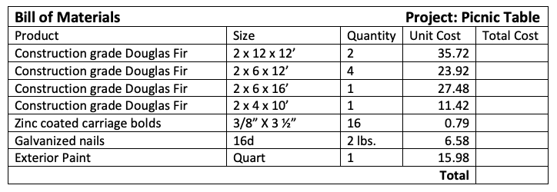

- An active learning strategy in which students pose questions, conduct investigations, and seek answers under the guidance and supervision of the teacher is called:
  - Direct Instruction
  - Independent Instruction
  - Inquiry Learning
  - Mastery Learning

- A system that creates, manages, analyzes, and maps agricultural data is called:
  - Geographic Information System (GIS)
  - Global Positioning System (GPS)
  - Telematics
  - Web Soil Survey (WSS)

- Which document provides accommodations, aids and services for students with disabilities?
  - 504 Plan
  - Individualized Education Program (IEP)
  - Students with Disabilities Plan (SDP)
  - Special Personalized Education Plan (SPED)

- Which learning philosophy is built on the premises that students construct knowledge from personal experiences, rather than passively absorbing information presented by teachers and others?
  - Cognitive Development
  - Constructivism
  - Information Processing
  - Social Emotional Learning

- This is the first degree a member who participates in FFA activities in 7th and 8th grade can earn:
  - American Degree
  - Discovery Degree
  - Greenhand Degree
  - State Degree

Answer Key:
- D
- A
- D
- D
- C
- B
- D
- C
- A
- B
- B
- B
- D
- B
- B
- B
- A
- C
- C
- C
- C
- A
- A
- B
- B

