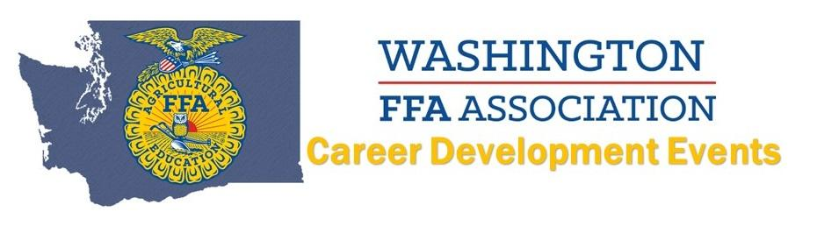
2021 Conduct of Chapter Meeting LDE
Top TEAMS:
4. Lynden
3. Sprague
2. Tonasket
1. Asotin

