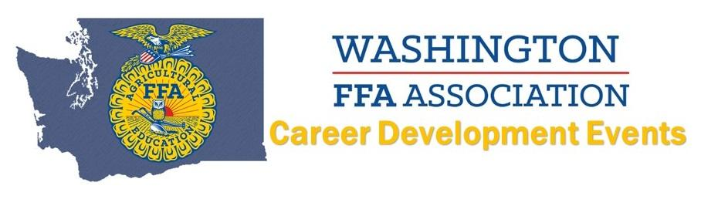
2021 Agronomy CDE
Top 10 INDIVIDUALS
(Name AND Chapter):
10. Lane Tellefson, Lind-Ritzville
9. Jesse Burke, Royal
8. Austin Kernn, Moses Lake 1
7. Traye Redburn, Lind-Ritzville
6. Samantha Fitzhugh, Royal
5. Macie Loutherback, Moses Lake 2
4. Taylor Galbreath, Lind-Ritzville
3. Samuel Otey, Moses Lake 1
2. Jenna Whitaker, Moses Lake 1
1. Tressa Wade, Moses Lake 1
Top 8 TEAMS:
5. Moses Lake 2
4. Garfield-Palouse
3. Royal
2. Lind-Ritzville
1. Moses Lake 1

