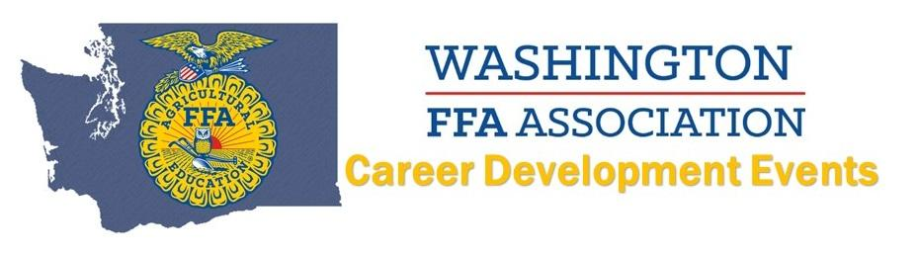
2021 Marketing Plan CDE
Top 8 TEAMS:
8. Ephrata
7. Pomeroy
6. Nooksack Valley – Cherry Hill
5. Nooksack Valley – Meatpies
4. Tonasket
3. LaCrosse
2. Lind-Ritzville
1. Ellensburg

