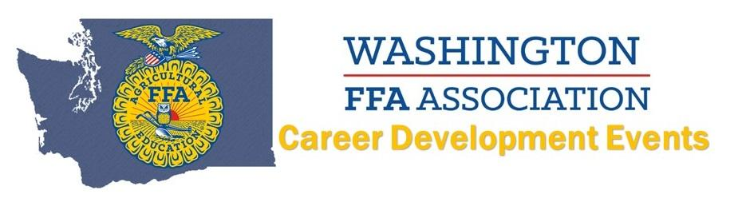
2021 Livestock CDE
Top 10 INDIVIDUALS
(Name AND Chapter):
10. Kyia Hunter, Moses Lake
9. Kenzie Paris, Asotin
8. Cole Devorak, Asotin
7. Ty Harder, LaCrosse
6. Bailey Sherley, Ellensburg
5. Raegan Snider, Lind-Ritzville
4. Alyssa Williams, Lind-Ritzville
3. Maggie Finch, Cashmere
2. Caylie Browne, Asotin
1. Lacee Sanford, Asotin
Top 8 TEAMS:
8. Oakesdale
7. Pomeroy
6. Moses Lake
5. LaCrosse
4. Ellensburg
3. Cashmere
2. Lind-Ritzville
1. Asotin

