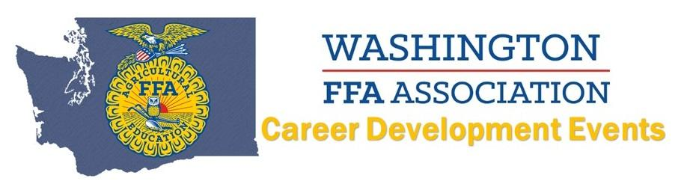
2021 Agricultural Skills
INDIVIDUALS - GOLD
(Name AND Chapter):
Jose Herrera - Wahluke
Juan Ramos - Wahluke
Breanna Allen - Cusick
Aaron Hoisington - Cusick
Meagan Hoisington - Cusick

