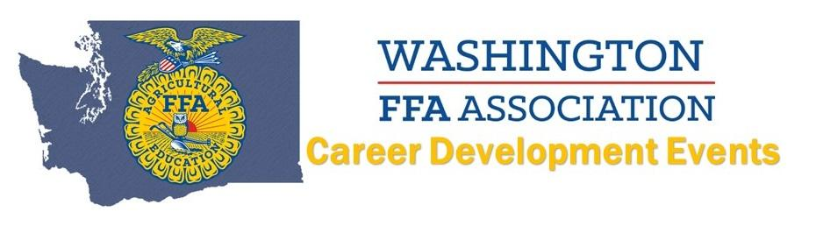
2021 Ag Issues Form LDE
Top TEAMS
(Name AND Chapter):
6. White River
5. Pullman
4. Elma - Timber
3. Ferndale
2. Yelm
1. Elma - Labor

