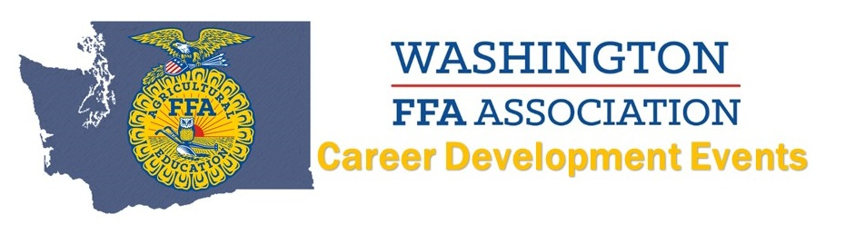
2021 Dairy Cattle Evaluation
Coordinator: Curt DeHaan
Top 10 INDIVIDUALS
(Name AND Chapter):
10. Jacob Tolsma, Lynden Christian
9. Megan Engelsma, Lynden Christian
8. Nicci Vermeer, Nooksack Valley
7. Socorro Scotto Rodriguez, Yelm
6. Nora Tarbox, Yelm
5. Amanda Lenssen, Lynden Christian
4. Maddie Zweegman, Lynden Christian
3. Jakob Huttmann, Yelm
2. Colton Cuperus, Nooksack Valley
1. Addie DeJong, Lynden Christian
Top 8 TEAMS:
3. Nooksack Valley
2. Yelm
1. Lynden Christian

