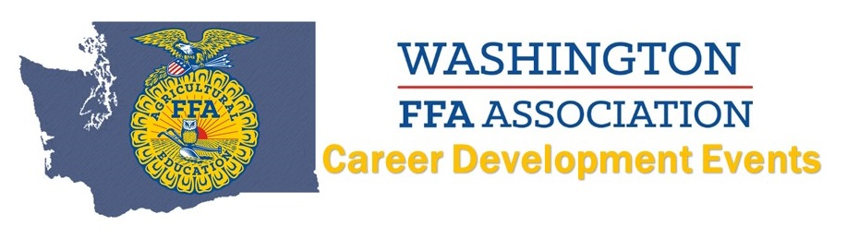
2017 State Nursery Landscape CDE
Coordinator: Tracy Brown
Top 10 INDIVIDUALS
(Name AND Chapter):
10. Zakya Misallati | Cedarcrest
9. Kaitlin Vaughn | Sedro Woolley
8. Sophia Fox | Sedro Woolley
7. Max Keller | Hudson's Bay Gold
6. Caitlyn Hansen | Hudson's Bay Black
5. Shauna Flores | Sedro Woolley
4. Lindsey Joyce | Sedro Woolley
3. Rhianna Bohn | Hudson's Bay Gold
2. Benny Benson | Cedarcrest
- Kendra Mutch | Cedarcrest
Top 8 TEAMS:
8. Fort Vancouver
7. Aberdeen
6. Stanwood
5. Hudson's Bay Black
4. Yelm
- Hudson's Bay Gold
- Sedro Woolley
- Cedarcrest

